Epic2: Project Setup and Configuration

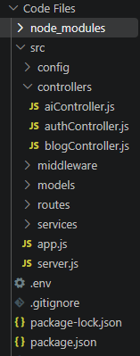

1. Server Setup (npm init)
The server setup process initializes the Node.js backend environment for the ContentGen application. It creates the project configuration file and establishes the basic folder structure required for backend development.

Steps:
1. Open Server Folder in VS Code Terminal:

Open the project folder in Visual Studio Code.

Open the integrated terminal.

Navigate to the server directory.

2. Initialize Node.js Project:
Run the following command:
npm init -y

Initializes a new Node.js project.

Automatically creates the package.json file.

Stores project information, dependencies, and scripts.

3. Create Server File:
Create the following file:
- server.js – Responsible for starting the backend server and listening for incoming requests.
4. Create Backend Folders:
Create the following folders:
Folder | Purpose
models | Defines database schemas and models using Mongoose.
controllers | Handles application logic and processes client requests.
routes | Defines API endpoints and connects them with controllers.

Expected Folder Structure
Server/
│
├── models/
├── controllers/
├── routes/
├── server.js
└── package.json
Overall Explanation:
The server setup establishes the basic backend environment using Node.js. The npm init -y command generates the project configuration file, while the server file and folders organize the application into separate modules for handling server operations, database management, request processing, and API routing.

